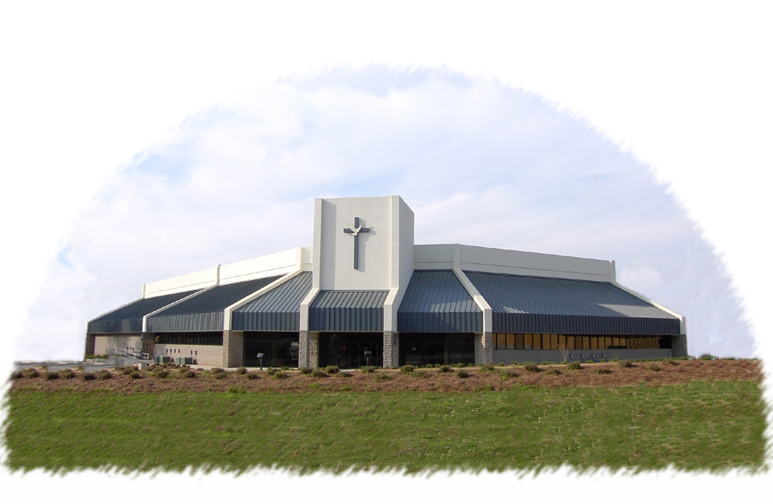
The Church
2001 Double Churches Rd
Columbus, GA 31909
www.thechurchofcolumbus.org
(706) 571-0919
Of Columbus


Perceiving The Potter’s Wheel
6/29/1997
Sun, PM
H.L. Sheppard

